Couch to 5K

Tuesday 16th April – Saturday 22nd June 2024
Would you like to run? If so we would love you to join our Couch to 5K Group. Our three, weekly sessions are designed to get you moving and increase your running confidence, with a target of completing a 5k Parkrun to celebrate the end the course. Sessions are led by qualified run leaders and are specifically designed for those who are just starting out, have limited running experience, or are returning to running after a break.

Sessions Tuesdays 18:15 to 19:15 at Holt Park Active Thursdays 19:30 to 20:30 at Bedquilts
Sundays 15:00 to 16:00 at Bedquilts

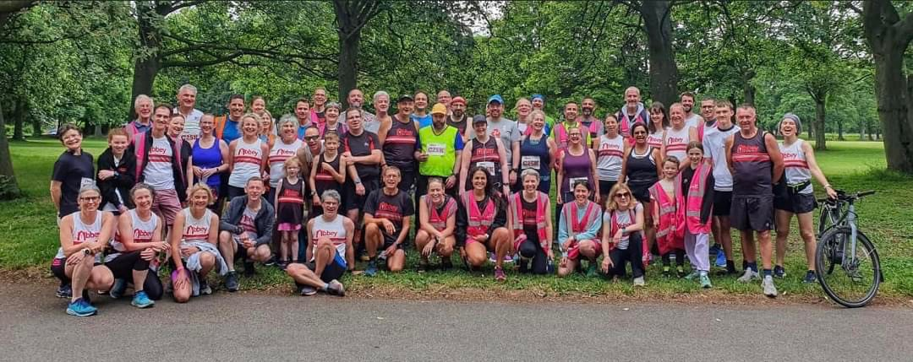
Apply online at https://www.abbeyrunners.co.uk or come and meet us, chat and take an introductory walk at our Club Open Night on Tuesday 9th April 19:15 at Holt Park Active, Holtdale Approach, Leeds LS16 7RX
C25K 2023

For more information please contact run@abbeyrunners.co.uk

